IEEE 118-bus

Unit and Network Data

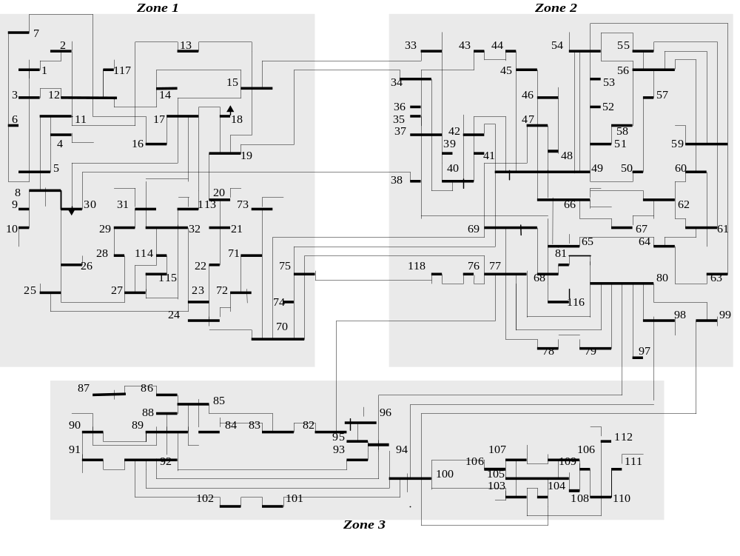
Fig. 1. The 118-bus system

table 1 transmission line data
Line No. | From Bus | To Bus | Circuit ID | R (pu) | X (pu) | B (pu) | Flow Limit (MW)
1 | 1 | 2 | 1 | 0.0303 | 0.0999 | 0.0254 | 175
2 | 1 | 3 | 1 | 0.0129 | 0.0424 | 0.01082 | 175
3 | 4 | 5 | 1 | 0.00176 | 0.00798 | 0.0021 | 500
4 | 3 | 5 | 1 | 0.0241 | 0.108 | 0.0284 | 175
5 | 5 | 6 | 1 | 0.0119 | 0.054 | 0.01426 | 175
6 | 6 | 7 | 1 | 0.00459 | 0.0208 | 0.0055 | 175
7 | 8 | 9 | 1 | 0.00244 | 0.0305 | 1.162 | 500
8 | 8 | 5 | 1 | 0 | 0.0267 | 0 | 500
9 | 9 | 10 | 1 | 0.00258 | 0.0322 | 1.23 | 500
10 | 4 | 11 | 1 | 0.0209 | 0.0688 | 0.01748 | 175
11 | 5 | 11 | 1 | 0.0203 | 0.0682 | 0.01738 | 175
12 | 11 | 12 | 1 | 0.00595 | 0.0196 | 0.00502 | 175
13 | 2 | 12 | 1 | 0.0187 | 0.0616 | 0.01572 | 175
14 | 3 | 12 | 1 | 0.0484 | 0.16 | 0.0406 | 175
15 | 7 | 12 | 1 | 0.00862 | 0.034 | 0.00874 | 175
16 | 11 | 13 | 1 | 0.02225 | 0.0731 | 0.01876 | 175
17 | 12 | 14 | 1 | 0.0215 | 0.0707 | 0.01816 | 175
18 | 13 | 15 | 1 | 0.0744 | 0.2444 | 0.06268 | 175
19 | 14 | 15 | 1 | 0.0595 | 0.195 | 0.0502 | 175
20 | 12 | 16 | 1 | 0.0212 | 0.0834 | 0.0214 | 175
21 | 15 | 17 | 1 | 0.0132 | 0.0437 | 0.0444 | 500
22 | 16 | 17 | 1 | 0.0454 | 0.1801 | 0.0466 | 175
23 | 17 | 18 | 1 | 0.0123 | 0.0505 | 0.01298 | 175
24 | 18 | 19 | 1 | 0.01119 | 0.0493 | 0.01142 | 175
25 | 19 | 20 | 1 | 0.0252 | 0.117 | 0.0298 | 175
26 | 15 | 19 | 1 | 0.012 | 0.0394 | 0.0101 | 175
27 | 20 | 21 | 1 | 0.0183 | 0.0849 | 0.0216 | 175
28 | 21 | 22 | 1 | 0.0209 | 0.097 | 0.0246 | 175
29 | 22 | 23 | 1 | 0.0342 | 0.159 | 0.0404 | 175
30 | 23 | 24 | 1 | 0.0135 | 0.0492 | 0.0498 | 175
31 | 23 | 25 | 1 | 0.0156 | 0.08 | 0.0864 | 500
32 | 26 | 25 | 1 | 0 | 0.0382 | 0 | 500
33 | 25 | 27 | 1 | 0.0318 | 0.163 | 0.1764 | 500
34 | 27 | 28 | 1 | 0.01913 | 0.0855 | 0.0216 | 175
35 | 28 | 29 | 1 | 0.0237 | 0.0943 | 0.0238 | 175
36 | 30 | 17 | 1 | 0 | 0.0388 | 0 | 500
37 | 8 | 30 | 1 | 0.00431 | 0.0504 | 0.514 | 175
38 | 26 | 30 | 1 | 0.00799 | 0.086 | 0.908 | 500
39 | 17 | 31 | 1 | 0.0474 | 0.1563 | 0.0399 | 175
40 | 29 | 31 | 1 | 0.0108 | 0.0331 | 0.0083 | 175
41 | 23 | 32 | 1 | 0.0317 | 0.1153 | 0.1173 | 140
42 | 31 | 32 | 1 | 0.0298 | 0.0985 | 0.0251 | 175
43 | 27 | 32 | 1 | 0.0229 | 0.0755 | 0.01926 | 175
44 | 15 | 33 | 1 | 0.038 | 0.1244 | 0.03194 | 175
45 | 19 | 34 | 1 | 0.0752 | 0.247 | 0.0632 | 175
46 | 35 | 36 | 1 | 0.00224 | 0.0102 | 0.00268 | 175
47 | 35 | 37 | 1 | 0.011 | 0.0497 | 0.01318 | 175
48 | 33 | 37 | 1 | 0.0415 | 0.142 | 0.0366 | 175
49 | 34 | 36 | 1 | 0.00871 | 0.0268 | 0.00568 | 175
50 | 34 | 37 | 1 | 0.00256 | 0.0094 | 0.00984 | 500
51 | 38 | 37 | 1 | 0 | 0.0375 | 0 | 500
52 | 37 | 39 | 1 | 0.0321 | 0.106 | 0.027 | 175
53 | 37 | 40 | 1 | 0.0593 | 0.168 | 0.042 | 175
54 | 30 | 38 | 1 | 0.00464 | 0.054 | 0.422 | 175
55 | 39 | 40 | 1 | 0.0184 | 0.0605 | 0.01552 | 175
56 | 40 | 41 | 1 | 0.0145 | 0.0487 | 0.01222 | 175
57 | 40 | 42 | 1 | 0.0555 | 0.183 | 0.0466 | 175
58 | 41 | 42 | 1 | 0.041 | 0.135 | 0.0344 | 175
59 | 43 | 44 | 1 | 0.0608 | 0.2454 | 0.06068 | 175
60 | 34 | 43 | 1 | 0.0413 | 0.1681 | 0.04226 | 175
61 | 44 | 45 | 1 | 0.0224 | 0.0901 | 0.0224 | 175
62 | 45 | 46 | 1 | 0.04 | 0.1356 | 0.0332 | 175
63 | 46 | 47 | 1 | 0.038 | 0.127 | 0.0316 | 175
64 | 46 | 48 | 1 | 0.0601 | 0.189 | 0.0472 | 175
65 | 47 | 49 | 1 | 0.0191 | 0.0625 | 0.01604 | 175
66 | 42 | 49 | 1 | 0.0715 | 0.323 | 0.086 | 175
67 | 42 | 49 | 2 | 0.0715 | 0.323 | 0.086 | 175
68 | 45 | 49 | 1 | 0.0684 | 0.186 | 0.0444 | 175
69 | 48 | 49 | 1 | 0.0179 | 0.0505 | 0.01258 | 175
70 | 49 | 50 | 1 | 0.0267 | 0.0752 | 0.01874 | 175
71 | 49 | 51 | 1 | 0.0486 | 0.137 | 0.0342 | 175
72 | 51 | 52 | 1 | 0.0203 | 0.0588 | 0.01396 | 175
73 | 52 | 53 | 1 | 0.0405 | 0.1635 | 0.04058 | 175
74 | 53 | 54 | 1 | 0.0263 | 0.122 | 0.031 | 175
75 | 49 | 54 | 1 | 0.073 | 0.289 | 0.0738 | 175
76 | 49 | 54 | 2 | 0.0869 | 0.291 | 0.073 | 175
77 | 54 | 55 | 1 | 0.0169 | 0.0707 | 0.0202 | 175
78 | 54 | 56 | 1 | 0.00275 | 0.00955 | 0.00732 | 175
79 | 55 | 56 | 1 | 0.00488 | 0.0151 | 0.00374 | 175
80 | 56 | 57 | 1 | 0.0343 | 0.0966 | 0.0242 | 175
81 | 50 | 57 | 1 | 0.0474 | 0.134 | 0.0332 | 175
82 | 56 | 58 | 1 | 0.0343 | 0.0966 | 0.0242 | 175
83 | 51 | 58 | 1 | 0.0255 | 0.0719 | 0.01788 | 175
84 | 54 | 59 | 1 | 0.0503 | 0.2293 | 0.0598 | 175
85 | 56 | 59 | 1 | 0.0825 | 0.251 | 0.0569 | 175
86 | 56 | 59 | 2 | 0.0803 | 0.239 | 0.0536 | 175
87 | 55 | 59 | 1 | 0.04739 | 0.2158 | 0.05646 | 175
88 | 59 | 60 | 1 | 0.0317 | 0.145 | 0.0376 | 175
89 | 59 | 61 | 1 | 0.0328 | 0.15 | 0.0388 | 175
90 | 60 | 61 | 1 | 0.00264 | 0.0135 | 0.01456 | 500
91 | 60 | 62 | 1 | 0.0123 | 0.0561 | 0.01468 | 175
92 | 61 | 62 | 1 | 0.00824 | 0.0376 | 0.0098 | 175
93 | 63 | 59 | 1 | 0 | 0.0386 | 0 | 500
94 | 63 | 64 | 1 | 0.00172 | 0.02 | 0.216 | 500
95 | 64 | 61 | 1 | 0 | 0.0268 | 0 | 500
96 | 38 | 65 | 1 | 0.00901 | 0.0986 | 1.046 | 500
97 | 64 | 65 | 1 | 0.00269 | 0.0302 | 0.38 | 500
98 | 49 | 66 | 1 | 0.018 | 0.0919 | 0.0248 | 500
99 | 49 | 66 | 2 | 0.018 | 0.0919 | 0.0248 | 500
100 | 62 | 66 | 1 | 0.0482 | 0.218 | 0.0578 | 175
101 | 62 | 67 | 1 | 0.0258 | 0.117 | 0.031 | 175
102 | 65 | 66 | 1 | 0 | 0.037 | 0 | 500
103 | 66 | 67 | 1 | 0.0224 | 0.1015 | 0.02682 | 175
104 | 65 | 68 | 1 | 0.00138 | 0.016 | 0.638 | 500
105 | 47 | 69 | 1 | 0.0844 | 0.2778 | 0.07092 | 175
106 | 49 | 69 | 1 | 0.0985 | 0.324 | 0.0828 | 175
107 | 68 | 69 | 1 | 0 | 0.037 | 0 | 500
108 | 69 | 70 | 1 | 0.03 | 0.127 | 0.122 | 500
109 | 24 | 70 | 1 | 0.00221 | 0.4115 | 0.10198 | 175
110 | 70 | 71 | 1 | 0.00882 | 0.0355 | 0.00878 | 175
111 | 24 | 72 | 1 | 0.0488 | 0.196 | 0.0488 | 175
112 | 71 | 72 | 1 | 0.0446 | 0.18 | 0.04444 | 175
113 | 71 | 73 | 1 | 0.00866 | 0.0454 | 0.01178 | 175
114 | 70 | 74 | 1 | 0.0401 | 0.1323 | 0.03368 | 175
115 | 70 | 75 | 1 | 0.0428 | 0.141 | 0.036 | 175
116 | 69 | 75 | 1 | 0.0405 | 0.122 | 0.124 | 500
117 | 74 | 75 | 1 | 0.0123 | 0.0406 | 0.01034 | 175
118 | 76 | 77 | 1 | 0.0444 | 0.148 | 0.0368 | 175
119 | 69 | 77 | 1 | 0.0309 | 0.101 | 0.1038 | 175
120 | 75 | 77 | 1 | 0.0601 | 0.1999 | 0.04978 | 175
121 | 77 | 78 | 1 | 0.00376 | 0.0124 | 0.01264 | 175
122 | 78 | 79 | 1 | 0.00546 | 0.0244 | 0.00648 | 175
123 | 77 | 80 | 1 | 0.017 | 0.0485 | 0.0472 | 500
124 | 77 | 80 | 2 | 0.0294 | 0.105 | 0.0228 | 500
125 | 79 | 80 | 1 | 0.0156 | 0.0704 | 0.0187 | 175
126 | 68 | 81 | 1 | 0.00175 | 0.0202 | 0.808 | 500
127 | 81 | 80 | 1 | 0 | 0.037 | 0 | 500
128 | 77 | 82 | 1 | 0.0298 | 0.0853 | 0.08174 | 200
129 | 82 | 83 | 1 | 0.0112 | 0.03665 | 0.03796 | 200
130 | 83 | 84 | 1 | 0.0625 | 0.132 | 0.0258 | 175
131 | 83 | 85 | 1 | 0.043 | 0.148 | 0.0348 | 175
132 | 84 | 85 | 1 | 0.0302 | 0.0641 | 0.01234 | 175
133 | 85 | 86 | 1 | 0.035 | 0.123 | 0.0276 | 500
134 | 86 | 87 | 1 | 0.02828 | 0.2074 | 0.0445 | 500
135 | 85 | 88 | 1 | 0.02 | 0.102 | 0.0276 | 175
136 | 85 | 89 | 1 | 0.0239 | 0.173 | 0.047 | 175
137 | 88 | 89 | 1 | 0.0139 | 0.0712 | 0.01934 | 500
138 | 89 | 90 | 1 | 0.0518 | 0.188 | 0.0528 | 500
139 | 89 | 90 | 2 | 0.0238 | 0.0997 | 0.106 | 500
140 | 90 | 91 | 1 | 0.0254 | 0.0836 | 0.0214 | 175
141 | 89 | 92 | 1 | 0.0099 | 0.0505 | 0.0548 | 500
142 | 89 | 92 | 2 | 0.0393 | 0.1581 | 0.0414 | 500
143 | 91 | 92 | 1 | 0.0387 | 0.1272 | 0.03268 | 175
144 | 92 | 93 | 1 | 0.0258 | 0.0848 | 0.0218 | 175
145 | 92 | 94 | 1 | 0.0481 | 0.158 | 0.0406 | 175
146 | 93 | 94 | 1 | 0.0223 | 0.0732 | 0.01876 | 175
147 | 94 | 95 | 1 | 0.0132 | 0.0434 | 0.0111 | 175
148 | 80 | 96 | 1 | 0.0356 | 0.182 | 0.0494 | 175
149 | 82 | 96 | 1 | 0.0162 | 0.053 | 0.0544 | 175
150 | 94 | 96 | 1 | 0.0269 | 0.0869 | 0.023 | 175
151 | 80 | 97 | 1 | 0.0183 | 0.0934 | 0.0254 | 175
152 | 80 | 98 | 1 | 0.0238 | 0.108 | 0.0286 | 175
153 | 80 | 99 | 1 | 0.0454 | 0.206 | 0.0546 | 200
154 | 92 | 100 | 1 | 0.0648 | 0.295 | 0.0472 | 175
155 | 94 | 100 | 1 | 0.0178 | 0.058 | 0.0604 | 175
156 | 95 | 96 | 1 | 0.0171 | 0.0547 | 0.01474 | 175
157 | 96 | 97 | 1 | 0.0173 | 0.0885 | 0.024 | 175
158 | 98 | 100 | 1 | 0.0397 | 0.179 | 0.0476 | 175
159 | 99 | 100 | 1 | 0.018 | 0.0813 | 0.0216 | 175
160 | 100 | 101 | 1 | 0.0277 | 0.1262 | 0.0328 | 175
161 | 92 | 102 | 1 | 0.0123 | 0.0559 | 0.01464 | 175
162 | 101 | 102 | 1 | 0.0246 | 0.112 | 0.0294 | 175
163 | 100 | 103 | 1 | 0.016 | 0.0525 | 0.0536 | 500
164 | 100 | 104 | 1 | 0.0451 | 0.204 | 0.0541 | 175
165 | 103 | 104 | 1 | 0.0466 | 0.1584 | 0.0407 | 175
166 | 103 | 105 | 1 | 0.0535 | 0.1625 | 0.0408 | 175
167 | 100 | 106 | 1 | 0.0605 | 0.229 | 0.062 | 175
168 | 104 | 105 | 1 | 0.00994 | 0.0378 | 0.00986 | 175
169 | 105 | 106 | 1 | 0.014 | 0.0547 | 0.01434 | 175
170 | 105 | 107 | 1 | 0.053 | 0.183 | 0.0472 | 175
171 | 105 | 108 | 1 | 0.0261 | 0.0703 | 0.01844 | 175
172 | 106 | 107 | 1 | 0.053 | 0.183 | 0.0472 | 175
173 | 108 | 109 | 1 | 0.0105 | 0.0288 | 0.0076 | 175
174 | 103 | 110 | 1 | 0.03906 | 0.1813 | 0.0461 | 175
175 | 109 | 110 | 1 | 0.0278 | 0.0762 | 0.0202 | 175
176 | 110 | 111 | 1 | 0.022 | 0.0755 | 0.02 | 175
177 | 110 | 112 | 1 | 0.0247 | 0.064 | 0.062 | 175
178 | 17 | 113 | 1 | 0.00913 | 0.0301 | 0.00768 | 175
179 | 32 | 113 | 1 | 0.0615 | 0.203 | 0.0518 | 500
180 | 32 | 114 | 1 | 0.0135 | 0.0612 | 0.01628 | 175
181 | 27 | 115 | 1 | 0.0164 | 0.0741 | 0.01972 | 175
182 | 114 | 115 | 1 | 0.0023 | 0.0104 | 0.00276 | 175
183 | 68 | 116 | 1 | 0.00034 | 0.00405 | 0.164 | 500
184 | 12 | 117 | 1 | 0.0329 | 0.14 | 0.0358 | 175
185 | 75 | 118 | 1 | 0.0145 | 0.0481 | 0.01198 | 175
186 | 76 | 118 | 1 | 0.0164 | 0.0544 | 0.01356 | 175

Table 2 Bus Load Distribution Profile
Bus No | Pd  (MW) | Qd  (MVAR)
1 | 54.14 | 8.66
2 | 21.23 | 9.55
3 | 41.4 | 10.62
4 | 31.85 | 12.74
6 | 55.2 | 23.35
7 | 20.17 | 2.12
11 | 74.31 | 24.42
12 | 49.89 | 10.62
13 | 36.09 | 16.99
14 | 14.86 | 1.06
15 | 95.54 | 31.85
16 | 26.54 | 10.62
17 | 11.68 | 3.18
18 | 63.69 | 36.09
19 | 47.77 | 26.54
20 | 19.11 | 3.18
21 | 14.86 | 8.49
22 | 10.62 | 5.31
23 | 7.43 | 3.18
27 | 65.82 | 13.8
28 | 18.05 | 7.43
29 | 25.48 | 4.25
31 | 45.65 | 28.66
32 | 62.63 | 24.42
33 | 24.42 | 9.55
34 | 62.63 | 27.6
35 | 35.03 | 9.55
36 | 32.91 | 18.05
39 | 27 | 11
40 | 20 | 23
41 | 37 | 10
42 | 37 | 23
43 | 18 | 7
44 | 16 | 8
45 | 53 | 22
46 | 28 | 10
47 | 34 | 0
48 | 20 | 11
49 | 87 | 30
50 | 17 | 4
51 | 17 | 8
52 | 18 | 5
53 | 23 | 11
54 | 113 | 32
55 | 63 | 22
56 | 84 | 18
57 | 12 | 3
58 | 12 | 3
59 | 277 | 113
60 | 78 | 3
62 | 77 | 14
66 | 39 | 18
67 | 28 | 7
70 | 66 | 20
74 | 68 | 27
75 | 47 | 11
76 | 68 | 36
77 | 61 | 28
78 | 71 | 26
79 | 39 | 32
80 | 130 | 26
82 | 54 | 27
83 | 20 | 10
84 | 11 | 7
85 | 24 | 15
86 | 21 | 10
88 | 48 | 10
90 | 78 | 42
92 | 65 | 10
93 | 12 | 7
94 | 30 | 16
95 | 42 | 31
96 | 38 | 15
97 | 15 | 9
98 | 34 | 8
100 | 37 | 18
101 | 22 | 15
102 | 5 | 3
103 | 23 | 16
104 | 38 | 25
105 | 31 | 26
106 | 43 | 16
107 | 28 | 12
108 | 2 | 1
109 | 8 | 3
110 | 39 | 30
112 | 25 | 13
114 | 8.49 | 3.18
115 | 23.35 | 7.43
117 | 21.23 | 8.49
118 | 33 | 15

